**Batch: D1 Roll No.: 16010123217**

**Experiment No. 04**

|  |
| --- |
| **TITLE:** **Develop and demonstrate JavaScript with POP-UP boxes and functions** |

**AIM:** To demonstrate the functionalities of JavaScript using HTML and CSS

**______________________________________________________________________**

**Expected Outcome of Experiment:** Design static web pages using various HTML tags.

**_______________________________________________________________**

**Books/ Journals/ Websites referred:**

1. .w3schools
2. Mdn web docs

**_____________________________________________________________________**

Describe and utilize Javascript programming concepts such as variables, arrays, conditionals, and loops.

Write and deploy Javascript code to solve practical web design problems.

**Problem Statement: Description of the application implemented with output**:

**a) Input**: Click on Display Date button using onclick( ) function

**Output:** Display date in the textbox

**b) Input:** A number n obtained using prompt

**Output:** Factorial of n number using alert

**c) Input:** A number n obtained using prompt

**Output:** A multiplication table of numbers from 1 to 10 of n using

d**) Write JavaScript to validate the following fields for the registration page**.

Name (Name should contain alphabets and the length should not be less than 6 characters).

Password (Password should not be less than 6 characters length).

E-mail id (should not contain any invalid and must follow the standard pattern

name@domain.com)

Phone number (Phone number should contain 10 digits only).

**Javascript Basic Concepts Learned With Syntax**

**1. Function Declaration**

function functionName() {

// Code to execute

}

Example:

function displayDate() {

let date = new Date();

document.getElementById("date").innerHTML = date;

}

**2. Variable Declaration (let)**

let variableName = value;

Example:

let date = new Date();

let factorial = 1;

**3. document.getElementById()**

document.getElementById("elementID").innerHTML = value;

Example:

document.getElementById("date").innerHTML = date;

**4. Creating a Date Object**

let date = new Date();

Example:

let date = new Date();

**5. Prompt Input from User**

let input = prompt("Enter a number:");

Example:

let num = prompt("Enter a number: ");

**6. For Loop**

for (let i = 0; i < limit; i++) {

// Code to execute

}

Example:

for (let i = 1; i <= num; i++) {

factorial *= i;

}

**7. String Template Literals (Template Strings)**

`Text ${variable} more text`

Example:

alert(`Factorial of ${num} is ${factorial}`);

**8. Alert Message**

alert("Message to display");

Example:

alert(`Factorial of ${num} is ${factorial}`);

**Description of the application implemented with output**:

Implementation of A), B) and C)

<!DOCTYPE html>

<html lang="en">

<head>

    <meta charset="UTF-8">

    <meta name="viewport" content="width=device-width, initial-scale=1.0">

    <title>Document</title>

</head>

<body>

    <h1>Name: Om Thanage</h1>

    <h1>Roll No: 16010123217</h1>

    <div style="display: flex; gap: 4rem; align-items: center; justify-content: space-between; width: 50vw;">

        <h1>A)</h1>

        <h1>Display Date</h1>

        <p id="date"></p>

        <button style="padding: 12px;" onclick="displayDate()">Get Date</button>

    </div>

    <div style="display: flex; gap: 4rem; align-items: center;  justify-content: space-between; width: 50vw;">

        <h1>B)</h1>

        <h1>Factorial</h1>

        <button style="padding: 12px;" onclick="getFactorial()">Get Factorial</button>

    </div>

    <div style="display: flex; gap: 4rem; align-items: center;  justify-content: space-between; width: 50vw;">

        <h1>C)</h1>

        <h1>Multiplication Table</h1>

        <button style="padding: 12px;" onclick="getTable()">Get Table</button>

    </div>

    <div style="width: 50vw; margin-top: 2rem;" id="table"></div>

    </div>

    <script>

        function displayDate() {

            let date = new Date();

            document.getElementById("date").innerHTML = date;

        }

        function getFactorial() {

            let num = prompt("Enter a number: ");

            let factorial = 1;

            for (let i = 1; i <= num; i++) {

                factorial *= i;

            }

            alert(`Factorial of ${num} is ${factorial}`);

        }

        function getTable() {

            let num = prompt("Enter a number: ");

            let table = "";

            for (let i = 1; i <= 10; i++) {

                table += `${num} x ${i} = ${num * i}<br>`;

            }

            document.getElementById("table").innerHTML = table;

        }

    </script>

</body>

</html>

**D)  
Register.html**

<!DOCTYPE html>

<html>

<head>

  <title>Registration Form</title>

  <style>

    body {

      font-family: Arial, sans-serif;

      background-color: #f4f4f4;

      display: flex;

      justify-content: center;

      align-items: center;

      height: 100vh;

    }

    form {

      background: white;

      padding: 20px;

      border-radius: 8px;

      box-shadow: 0px 0px 10px 0px rgba(0, 0, 0, 0.1);

    }

    label {

      display: block;

      margin-top: 10px;

    }

    input[type="text"], input[type="password"], input[type="email"], input[type="number"] {

      width: 90%;

      padding: 8px;

      margin-top: 5px;

      border: 1px solid #ccc;

      border-radius: 4px;

    }

    input[type="submit"] {

      margin-top: 15px;

      background: #5cb85c;

      color: white;

      border: none;

      padding: 10px;

      cursor: pointer;

      width: 100%;

      border-radius: 4px;

    }

    input[type="submit"]:hover {

      background: #4cae4c;

    }

  </style>

</head>

<body>

  <form>

    <label for="name">Name:</label>

    <input type="text" id="name" name="name"

           title="Name should contain only alphabets and be at least 6 characters long" />

    <br>

    <label for="password">Password:</label>

    <input type="password" id="password" name="password"

           minlength="6" required

           title="Password should be at least 6 characters long" />

    <br>

    <label for="email">Email:</label>

    <input type="email" id="email" name="email"

           pattern="^[a-zA-Z0-9._%+-]+@[a-zA-Z0-9.-]+\.[a-zA-Z]{2,}$" required

           title="Enter a valid email address (e.g., user@domain.com)" />

    <br>

    <label for="phone">Phone:</label>

    <input type="number" id="phone" name="phone"

           pattern="[0-9]{10}" required

           title="Phone number should contain exactly 10 digits" />

    <br>

    <input type="submit" value="Register">

  </form>

</body>

</html>

**Output:**

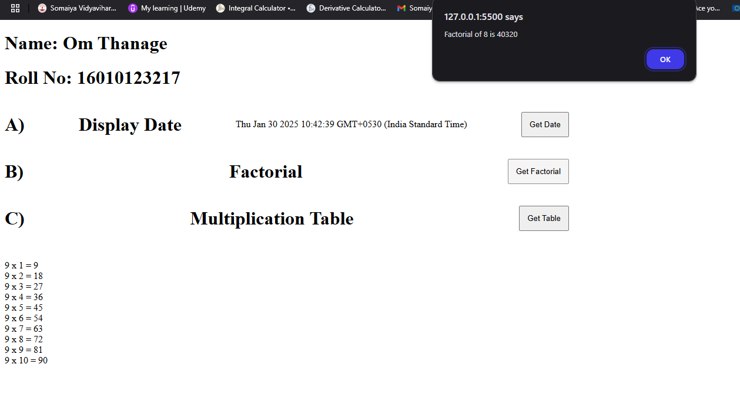

**Register.html**

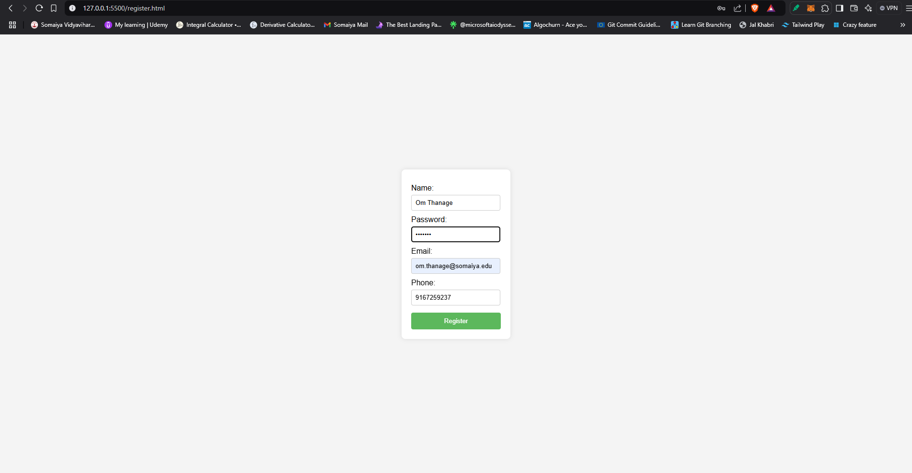

**Post Lab Objective with Ans :**

What are the possible ways to create objects in JavaScript?

Ans. JavaScript offers several ways to create objects:

1. **Object literals:** const obj = { key: 'value' }; (Simplest, for single objects)
2. **new Object():** const obj = new Object(); obj.key = 'value'; (Less common)
3. **Constructor functions:** function MyObject(key) { this.key = key; } const obj = new MyObject('value'); (For creating multiple similar objects)
4. **Classes (ES6+):** class MyObject { constructor(key) { this.key = key; } } const obj = new MyObject('value'); (Modern, preferred approach for complex objects)
5. **Object.create():** const parent = { key: 'parentValue' }; const obj = Object.create(parent); obj.key = 'value'; (Creates an object with a specific prototype)

What is the Difference between == and === operators?

Ans. The core difference between the == and === operators in JavaScript lies in how they handle type coercion during comparison:

* **== (Loose Equality):** This operator performs type coercion if the operands being compared have different types. It attempts to convert them to a common type before making the comparison. This can sometimes lead to unexpected results.
* **=== (Strict Equality):** This operator does not perform type coercion. It checks for both value and type equality. If the operands have different types, the comparison will always return false.

What is the difference between let and var?  
Ans. var and let are both used to declare variables in JavaScript, but they have key differences in scope and hoisting:

1. **Scope:** var has function scope (accessible within the entire function), while let has block scope (accessible only within the block where it's defined, like within an if statement or loop).
2. **Hoisting:** var variables are hoisted to the top of their scope and initialized with undefined, while let variables are hoisted but not initialized (accessing them before declaration results in an error).
3. **Redeclaration:** var allows redeclaration of the same variable within its scope, whereas let does not allow redeclaration in the same scope.
4. **Global Scope:** When declared in the global scope, var creates a property on the window object (in browsers), while let does not.
5. **Temporal Dead Zone:** Variables declared with let fall into a “temporal dead zone” before their actual declaration, where they cannot be accessed. This helps prevent unexpected behavior.